* Connect the Bluetooth module HC-05 as shown in the diagram. 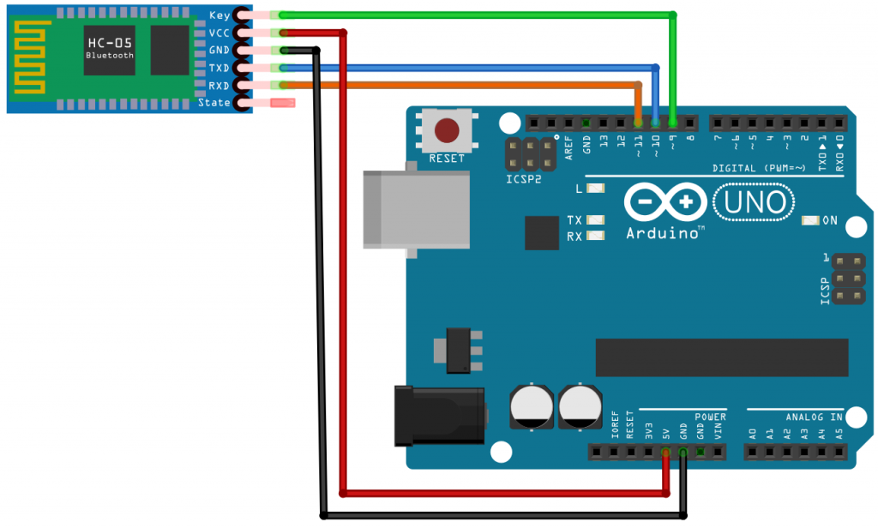
* Copy and paste the Name change program to arduino ide.
* Change the COM to 38400 baud rate and select “both NL and CR”
* You will see a place to type AT command
* Type “at” and send, if you see OK then your module is in set up mode,
* To change the name type “at+name=required_name” and send